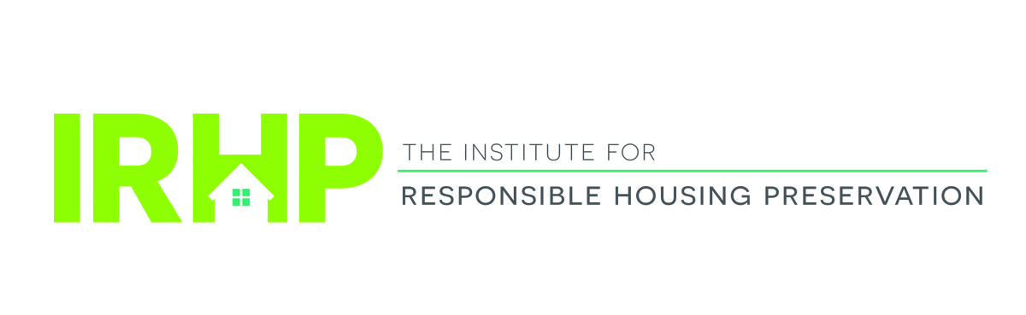

Institute for Responsible Housing Preservation

Preserving Affordable Housing Forum: A Look Forward

The Roosevelt Hotel – January 16, 2019

8:00 AM—9:00 AM Breakfast and Registration

9:00 AM—10:00 AM Private Equity in Affordable Housing Deals
Moderator: Aaron Yowell
Darga/Davis/Gropper/Harrison/Plattner
Volume cap scarcity and increased attention to serving a wider range of incomes have pushed developers to innovate new models for project equity. Private equity investors, fund managers, affordable housing developers and government leaders will discuss the challenges and opportunities for new structures using real world examples and examining new tools, including Opportunity Zones.

10:00 AM—11:00 AM Equity and Debt: Financing Your Deal
Moderator: Alex Viorst
Garland/Gillespie/Maxwell/Napolitano
Debt and equity providers will provide an update on the trends in the marketplace, including equity pricing predictions, interest rates, investor outlook/concerns and FHA.

11:00 AM—11:15 AM Networking Break

11:15 AM—12:15PM

Stepped Up Lead Based Paint Evaluation and Enforcement
Moderator: Richard Price
Santa/Sarett
HUD Secretary Carson has made lead-based paint inspection and remediation one of his top priorities. At the same time New York City has taken a renewed interest in possibly stiffening requirements. We will discuss requirements with renewed focus, and basics of complying with Federal lead paint notices to tenants, and lead paint remediation and documentation.

12:15 PM—1:15 PM Complimentary Luncheon

1:15 PM—1:30 PM Special Guest Speaker, Chuck Edson

1:30 PM—2:30 PM New York State/New York City Housing Officials
Moderator: Deborah VanAmerongen
Froehlich/Koepnick/LaBotz/Monaghan/Sokolow
Senior state and city housing officials discuss how these innovative agencies in New York are working to preserve vital affordable housing using creative financing structures.

2:30 PM—3:30PM Preservation Transactions: Getting It Done!
Moderators: John Kelly and Joe Lynch
Walsh/Williams
A candid discussion of doing deals in New York and elsewhere in the current environment. Discussion points include structuring a preservation transaction and a review of the key issues in preserving the aging federal and state assisted housing portfolio.

3:30 PM—3:45 PM Networking Break

3:45PM—5:00PM Washington DC Update
Moderator: Steve Wallace
Flaherty/Gasson/Soroka/Sussman
A comprehensive review of affordable housing and tax legislative and policy initiatives on Capitol Hill and HUD, including fixing the 4% LIHTC, 2019 HUD appropriations, Section 8 renewals and RAD.

5:00PM—6:30 PM Networking Reception

Co-Chairs
Stephen J Wallace, Nixon Peabody LLP
John Kelly, Nixon Peabody LLP
Joseph Lynch, Nixon Peabody LLP

Invited Speakers
Kim Darga, NYC Department of Housing Preservation and Development
Lisa Davis, PGIM Financial
Charles L Edson, Nixon Peabody LLP
Timothy Flaherty, Flaherty Salmin CPAs
Rich Froehlich, HDC
Sarah Garland, CBRE
David Gasson, Boston Capital
Jim Gillespie, Bellwether Enterprise Real Estate Capital
Rick Gropper, Camber Property Group LLC
Louis A Harrison, Belveron Partners
Rebecca Koepnick, New York Homes & Community Renewal
Kerry LaBotz, NYC Department of Housing Preservation and Development
Thomas Maxwell, RBC Capital Markets
Myles Monaghan, New York Homes & Community Renewal
Steve Napolitano, Boston Financial Investment Management
Josh Plattner, Jonathan Rose Companies
Richard M Price, Nixon Peabody LLP
Dean J Santa, NY/NJ Multifamily Asset Management
Josh Sarett, ALC Environmental
Arden Sokolow, New York City Housing Authority
Kathie Soroka, Nixon Peabody LLP
Monica Sussman, Nixon Peabody LLP
Deborah VanAmerongen, Nixon Peabody LLP
Alex Viorst, PGIM Financial
Dave Walsh, JP Morgan Chase
Carolyn Williams, NYC, Department of Housing Preservation and Development
Aaron Yowell, Nixon Peabody LLP

