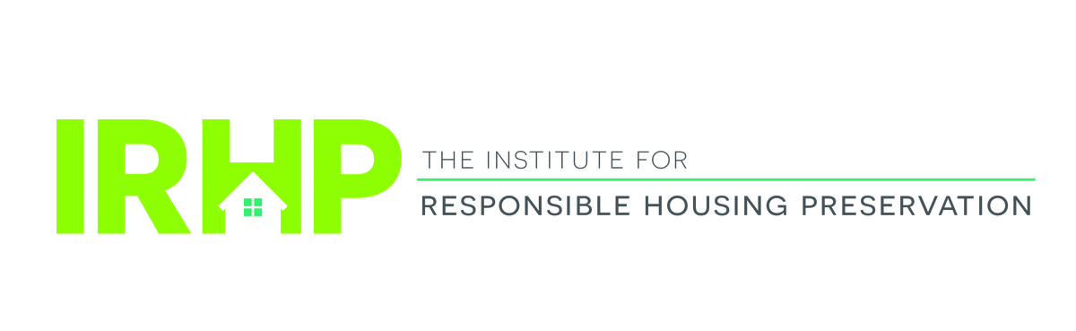

Institute for Responsible Housing Preservation

Affordable Housing Preservation Symposium:

Old Challenges, New Techniques

The Roosevelt Hotel – January 22, 2020

8:00 AM—9:00 AM Breakfast and Registration

9:00 AM—10:00 AM Washington DC Update
Moderator: Wallace
Gasson/Lawrence/Muha/Sussman
A comprehensive review of affordable housing and tax legislation and policy initiatives on Capitol Hill and HUD, including fixing the 4% LIHTC, 2020 HUD appropriations and Section 8 renewals.

10:00 AM—11:00 AM Rental Assistance Demonstration Program (RAD) Updates
Moderator: VanAmerongen
Froehlich/Soroka/Stokes
Our panelists will discuss the intricacies of the RAD program, which provides project-based subsidy to leverage private resources to preserve public housing, along with other tools being used by HUD and public housing agencies to reposition their housing. You’ll hear the latest on the use of RAD and Section 18, and an update on NYCHA’s PACT developments.

11:00 AM—11:15 AM Networking Break

11:15 AM—12:15PM New York State/New York City Housing Officials
Moderators: J Kelly/Lynch
Ferreira/McManus/Richardson
Senior state and city housing officials discuss how these innovative agencies in New York are working to preserve vital affordable housing using creative financing structures.

12:15 PM—1:15 PM Complimentary Luncheon

1:15 PM—2:30 PM Financing Your Preservation Deal
Moderator: Viorst
Grossman/Hessick/Neumann/Williams
Debt providers, including Fannie and Freddie, will provide an update on the latest trends in the marketplace for preservation acquisitions, including bridge loans.

2:30 PM—3:30PM The View From HUD

Moderator: Wallace

Santa/Sussman

HUD officials are invited to discuss new and existing policy initiatives and provide an update on the new REAC process, as well as RAD for Section 8 mod rehab and Section 202 PRAC properties.

3:30 PM—3:45 PM Networking Break

3:45PM—5:00PM Preservation Transactions: Getting Your Deal Closed!

Moderator: Altidor

Bindra/Germansky/Harrison/Yowell
A candid discussion of doing deals in New York and elsewhere in the current environment. Discussion points include structuring a preservation transaction using private equity and a review of the key issues in preserving the aging federal and state assisted housing portfolios.

5:00PM—6:30 PM Networking Reception

Co-Chairs
Steve Wallace, Nixon Peabody LLP
Randy Kelly, Foundation Housing

Invited Speakers
Meghan Altidor, Nixon Peabody LLP
Melissa Bindra, Camber Group
Nicole Ferreira, New York State Homes and Community Renewal
Rich Froehlich, NYCHDC
David Gasson, Boston Capital
Andrew Germansky, Westhab, Inc.
Rachel Grossman, JP Morgan Chase
Louis A Harrison, Belveron Partners
Georgia Hessick, Fannie Mae
John Kelly, Nixon Peabody LLP
Peter Lawrence, Novogradac & Company
Joe Lynch, Nixon Peabody LLP
Tim McManus, Catholic Charities
Denise Muha, National Leased Housing Association
Kent Neumann, Tiber Hudson
Anthony Richardson, New York City Housing Development Corporation
Dean Santa, HUD
Kathie Soroka, Nixon Peabody LLP
Amy Stokes, Monadnock Development
Monica Sussman, Nixon Peabody LLP
Deborah VanAmerongen, Nixon Peabody LLP
Alex Viorst, PGIM Real Estate
Arthanais Williams, Freddie Mac
Aaron Yowell, Nixon Peabody LLP

