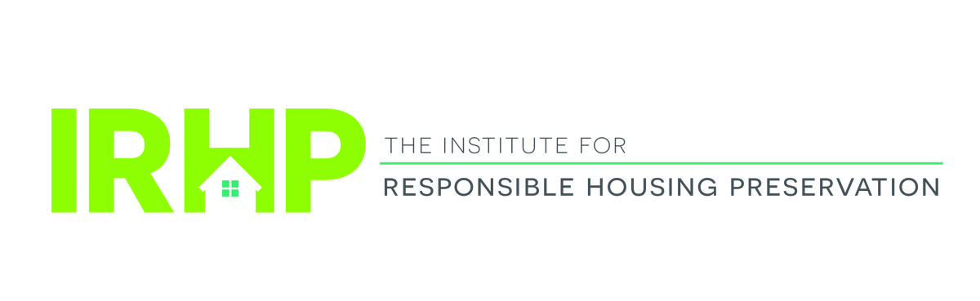

Institute for Responsible Housing Preservation

Affordable Housing Preservation Symposium: Old Challenges, New Techniques

The Roosevelt Hotel – January 22, 2020

8:00 AM—9:00 AM Breakfast and Registration

9:00 AM—10:00 AM Washington DC Update
A comprehensive review of affordable housing and tax legislative and policy initiatives on Capitol Hill and HUD, including fixing the 4% LIHTC, 2020 HUD appropriations and Section 8 renewals.

10:00 AM—11:00 AM Rental Assistance Demonstration Program (RAD) Updates
Our panelists will discuss the intricacies of the RAD program, which provides project-based subsidy to leverage private resources to preserve public housing, mod rehab, RAP/Rent Supp properties as well as section 202 PRACs.

11:00 AM—11:15 AM Networking Break

11:15 AM—12:15PM New York State/New York City Housing Officials
Senior state and city housing officials discuss how these innovative agencies in New York are working to preserve vital affordable housing using creative financing structures.

12:15 PM—1:15 PM Complimentary Luncheon

1:30 PM—2:30 PM Equity and Debt: Financing Your Deal
Debt and equity providers will provide an update on the trends in the marketplace, including equity pricing predictions, interest rates and investor outlook/concerns.

2:30 PM—3:30PM The View From HUD
HUD officials are invited to discuss new and existing policy initiatives and provide an update on the new REAC process.

3:30 PM—3:45 PM Networking Break

3:45PM—5:00PM Preservation Transactions: Getting Your Deal Closed!
A candid discussion of doing deals in New York and elsewhere in the current environment. Discussion points include structuring a preservation transaction and a review of the key issues in preserving the aging federal and state assisted housing portfolios.

5:00PM—6:30 PM Networking Reception

